Forgot Password/Reset Password


Go to digitalcookie.girlscouts.org and click the “Forgot password” link.

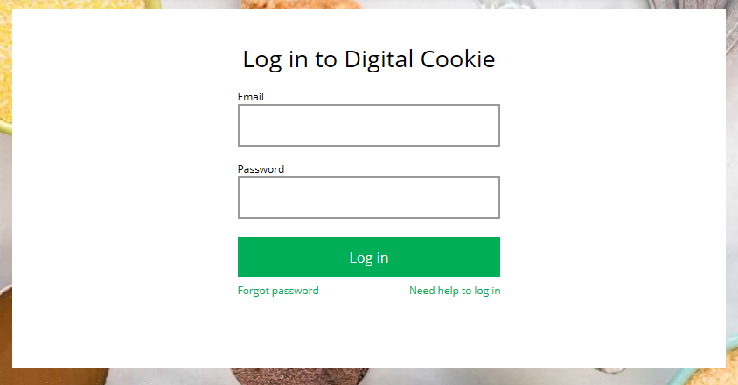

Enter the email address associated with your Girl Scout’s Digital CookieTM registration.
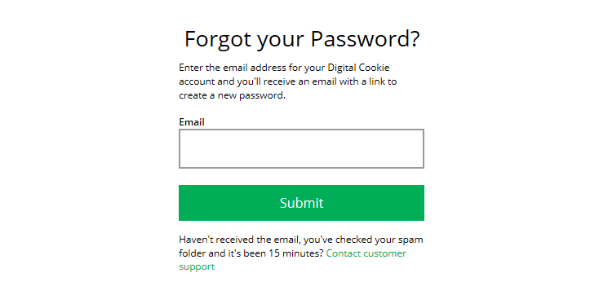

You will be sent an email with the subject: “Your Digital Cookie password change” from “Girl Scout Cookies” (email@email.girlscouts.org) in about 15 minutes. Check your junk/spam/promotions if you don’t receive it and be sure to add email@email.girlscouts.org to your “safe sender” list.
Click on the most recent email you received if you have requested multiples.

Open the email and click on the “Reset” link.

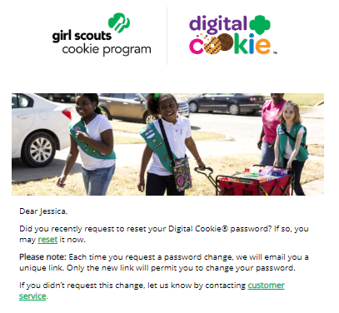

You will be taken to a page to reset your password.

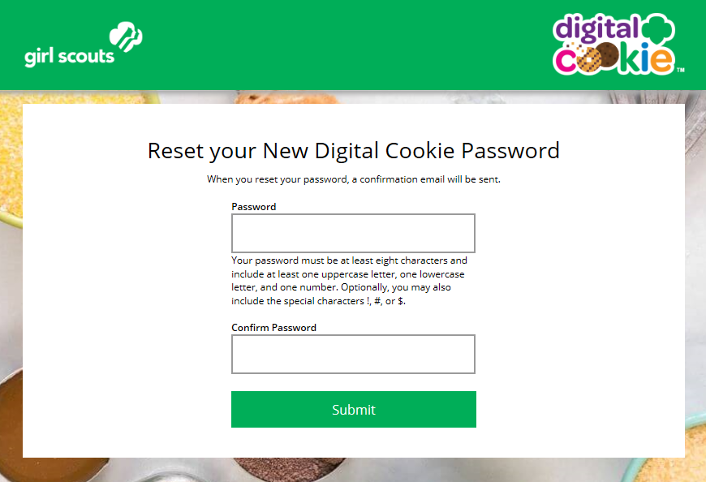
Enter your new password.


If you do not receive an email to reset your password in 15 minutes, return to the login page in step 1 again, click “forgot password” and this time select “Contact Customer Support” to be taken to a customer service form.

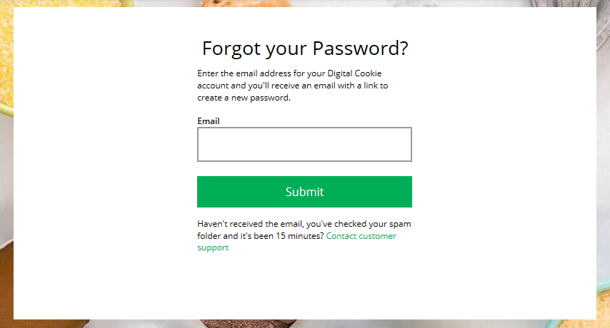


Select “Password Reset” to be complete information so we can assist you.

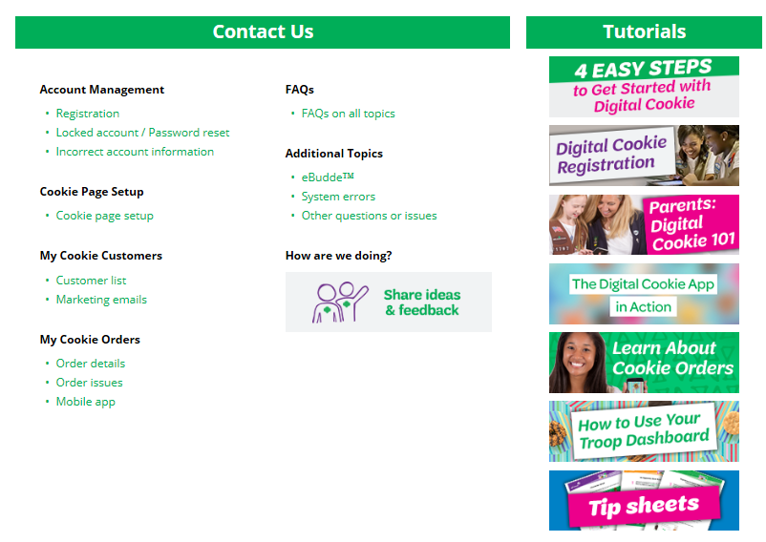

NEXT STEPS: Site Registration
Site Setup

